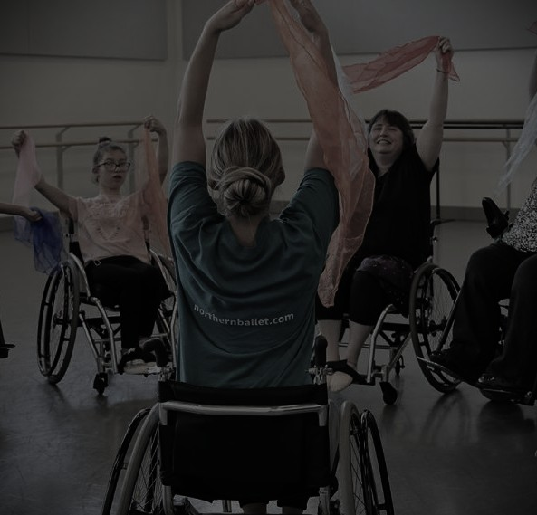
SEND dance workshops

Our effective SEND-A-PERFORMER workshops are structured, consistent and inclusive, they prioritise safety, comfort and creative expression. In the dance part of our SEND performing workshop we look at key elements including starting and ending with a familiar routine, using sensory props and incorporating Makaton signing to support communication.
Consistent Structure
- The welcome- 5-10 mins to get everyone feeling safe and used to the space and to explain what we are doing to help with transitions.
- Warm up- getting the body ready from head to toe, an accessible for all warm up style.
- Skill building- Introduction of small manageable choreography or specific movements (depending on level and need of students).
- Creative exploration- Free movement allowing improvisation and use of props such as scarves, ribbons, bells, to express themes.
- Cool down/ relaxation and reflection- Reflecting on the dance or moves learnt, and doing gentle stretches to bring energy down with relaxation at the end and a goodbye to help with the transition to the next space.
Acting Structure
- The welcome and a physical warm up- introduction to myself and the workshop, followed by a physical and accessible warm up, and drama games.
- The stage- learn about the stage and the structure, work on embodying physical characterisation, start to get comfortable working in pairs or groups on improvisation.
- Group piece - work on a piece all together or small short group pieces, learning about timing and action and reaction and embodying and remaining in character.
Workshop Intensity/ duration
Dance
- EYFS/KS1(early years) - small, repetitive sessions, high energy, short bursts of activity, and props.
- KS2-KS4- Longer sessions, slightly more complex choreography, partner work and creative exploration with props.
- Adults- Longer sessions, more complex choreography ( if accessible looking at specific styles), partner work, group work, creative exploration with props in a structured piece.`
All of our SEND workshops contain familiarity, inclusive communication, seated/standing options, use of props to engage and inclusive formations so everyone can see the facilitator and each other.
Acting
- EYFS/KS1- small sessions, short and fast paced to ensure engagement.
- KS2-KS4- A more complex session, looking at drama games, characterisation, confidence, the theatre structure, and allowing for self creative work in groups or partners.
- Adults- A more complex session, including drama games, character work, confidence building in improv, self creative work in groups or partners and structured script work (if accessible).
On booking please specify which workshop your interested in, also the working age of students, specific needs of the group and the aim/ theme of the session.
All workshops in our cultural section are also accessible to SEND students.

