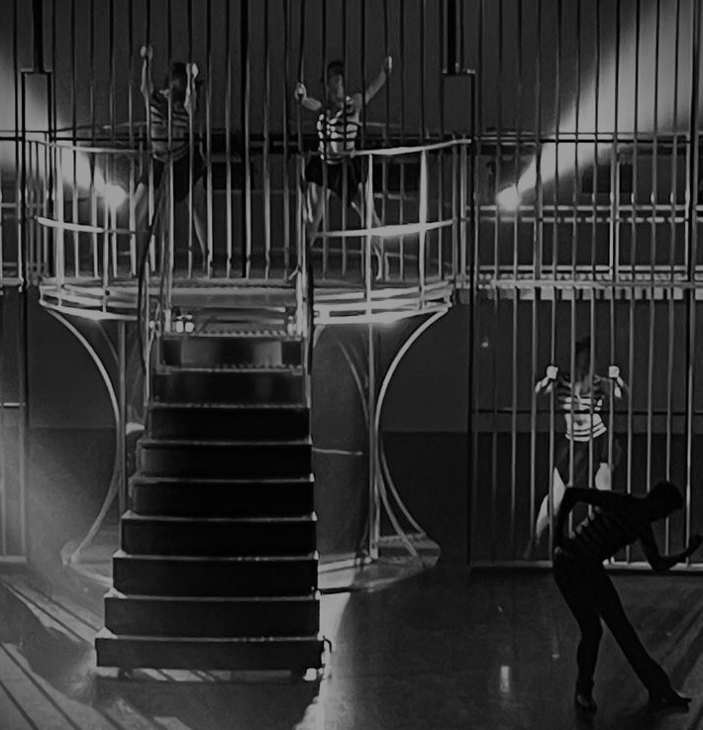
Professional industry dance workshops

In our professional dance industry workshop, participants can expect a well rounded and realistic insight into what it takes to train, perform, and succeed in the dance world.

STRUCTURE:
- The session will begin with a structured warm up and finish with an effective cool down, highlighting the importance of preparing the body properly and preventing injury - something every dance prioritises.

- Next we will focus on technique, working on core skills that underpin all styles of dance. Dancers will then explore a chosen style or learn a piece pf professional contract choreography, giving a genuine feel for the level, pace, and expectations found in the industry.

- Beyond movement, the workshop will also touch on health and mental wellbeing, addressing how dancers can maintain balance, resilience, and longevity in what can be a demanding career.

- Finally, we will look at what it takes to succeed not just as a performer, but as your own business- covering mindset, professionalism, self-promotion,and the realities of building a sustainable career in the dance and performing industry.

Overall, its an opportunity to train, learn, and gain honest insight into the professional world of dance.

STYLES OFFERED:

Jazz- including MT jazz, commercial jazz, and fusion jazz.

Bollywood & Bhangra- a rising popular style the same to that found in current music videos.
Contract & structured pieces- this will be choreography from previous contracts undertaken and also concept ideas, such as MT dance pieces, commercial video style pieces, dancing for an artist, and dance on camera.

This is a tailored workshop to your needs, please state on booking what style you require and the age of students so that i can pitch the workshop appropriately.

