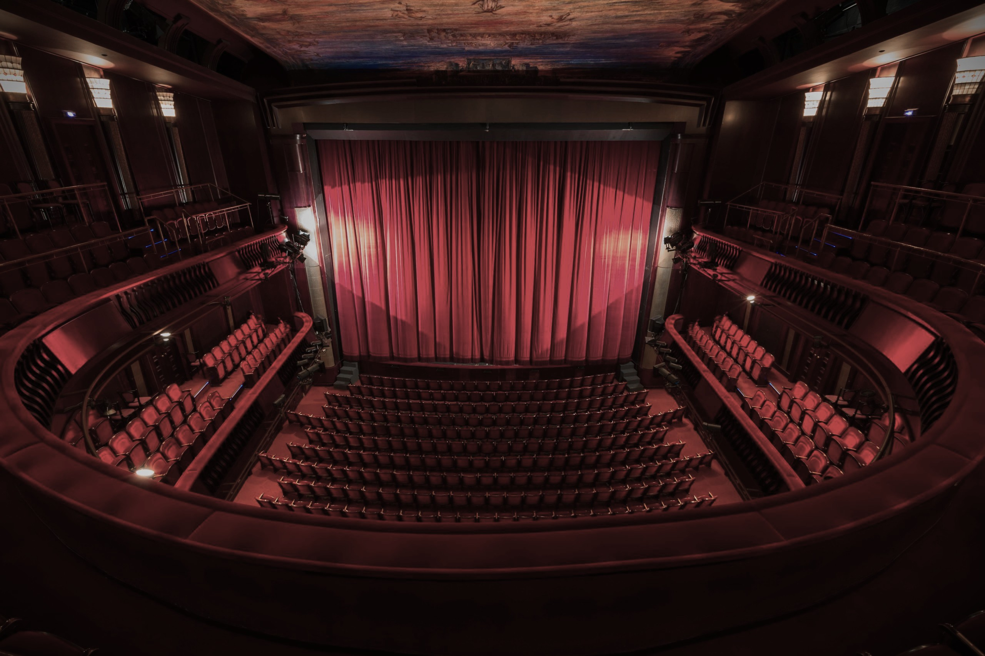

World of Musicals

Our musical theatre dance workshops are fun, high energy experiences where students step into the world of stage performance through movement, music and imagination. Inspired by well known theatre musicals the workshop introduces students to storytelling through dance, in a way that feels playful, inclusive and exciting.

WHAT TO EXPECT:

- Warm up games to get the body moving and break the ice.
- Simple choreography inspired by musical theatre styles.
- Creative tasks such as: Making up their own dance moves or mini performances
- Group routines ending in a short performance

BENEFITS:

- Confidence building - Students are encouraged to express themselves throughout fear of getting it wrong
- Team work and communication - Working together to create and perform routines
- Physical Development - Improving co-ordination, balance and rhythm
- Listening and Focus - Following instructions and responding to music ques.

INSIGHTS:

- How performers use movement, expression and storytelling on stage.
- The idea of rehearsal and performance like professional productions.
- Different roles within theatre such as dancers, choreographers and directors.
- The excitement of being part of a creative production process

This workshop is a joyful introduction to the world of musical theatre that can spark curiosity, build confidence and inspire a life long love of music, dance and theatre.

On booking please specify either what musicals you are wanting to look at or tailored advice

