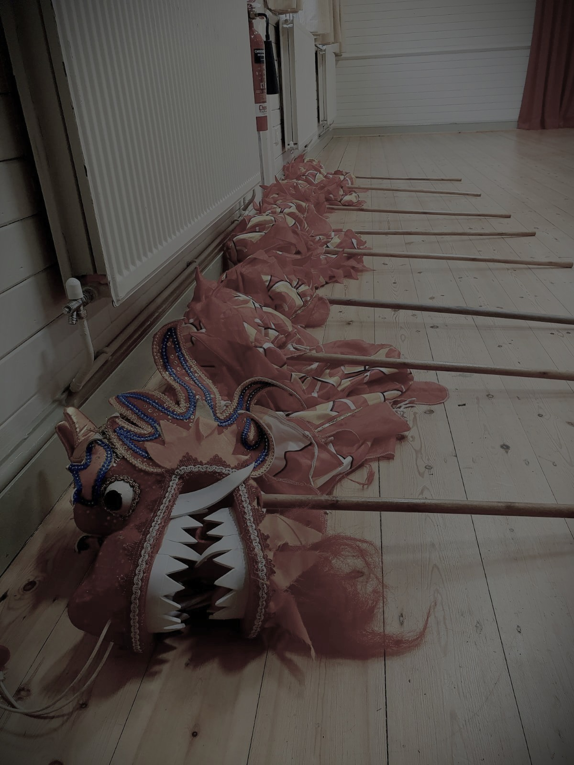
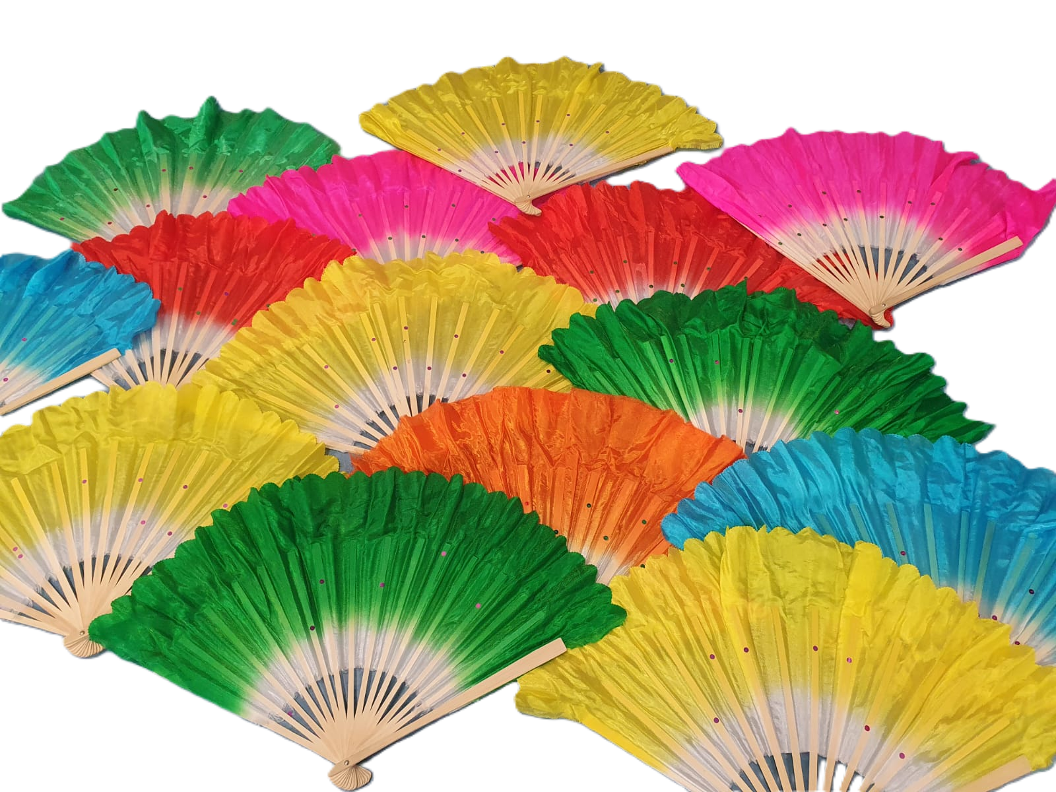

Chinese Dance Workshop

Chinese traditional dance workshops that focus on the celebration of Chinese new year. We offer a vibrate, hands on way to explore Chinese culture, storytelling and symbolism through the use of a number of props. These workshops aren’t just about movement they combine history, music, visual art and team work to bring an important cultural festival to life.

CULTURAL BACKGROUND:
Chinese new year also known as the spring festival marks the beginning of the luna calendar and is one of the most significant celebrations in Chinese culture, with different animals being celebrated each year. It is a time for renewal, family reunions, and welcoming good fortune. Traditional dances performed during this period are believed to bring luck, chase away evil spirits, and celebrate prosperity.

- Lion and dragon heads - the lion dances performed with large colourful lion and dragon head costumes
- Large dragon - A parade performed using a number of students working in unison operating large poles and rhythmic movements to make the dragon come alive.
- Dragon ribbons - Long ribbons attached to sticks using Chinese cultural dance movements.
- Parasol - students use decorative parasols in different patterns gracefully.
- Fans - Students use fans in different rhythms, levels and shapes to emulate artistic expression

Performance opportunities to showcase the work learnt in the session are available on request. Book via website

