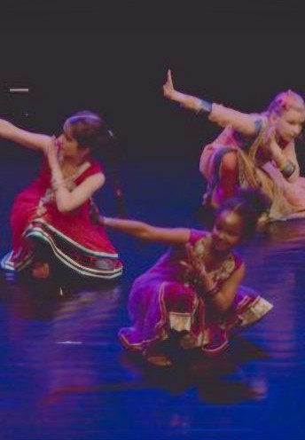

Indian Dance Workshops

Indian and Bollywood dance workshops are lively, expressive session where students learn both traditional and modern Indian dance styles while exploring the cultural stories behind them. These workshops aren’t just about movement they connect dance to history, celebration, music, and story telling in Indian culture
Students will begin by learning traditional steps and hand gestures also called Mudras. Which will when be formed into a routine that can be performed to the class or the rest of the school.

In the Bollywood dance workshops the style is more modern and energetic, it blends classical Indian dance with Hip Hop, Jazz and contemporary styles. Students learn expressive routines inspired by popular songs from Indian films focusing on performance, confidence and group co-ordination.
WHAT TO EXPECT:
Classical Indian:
- Bharatanatyam - a south Indian style, known for precise movements and story telling
- Kathak - from north Indian featuring intricate movements, turns and rhythmic footwork, often paired with Ghungroo, (ankle bells used the help with rhythm)
- Bhangra - a high energy Punjabi folk dance
- Bollywood - Modern choreography focusing on style, performance and Mudras (hand gestures)
Dance plays a huge role in Indian festivals, these workshops are popular with celebrations such as: Diwali (the festival of light) where dance celebrates good over evil. Holie (festival of colours) , and weddings which often include Bollywood dance performances
Please refer back to website for bookings

