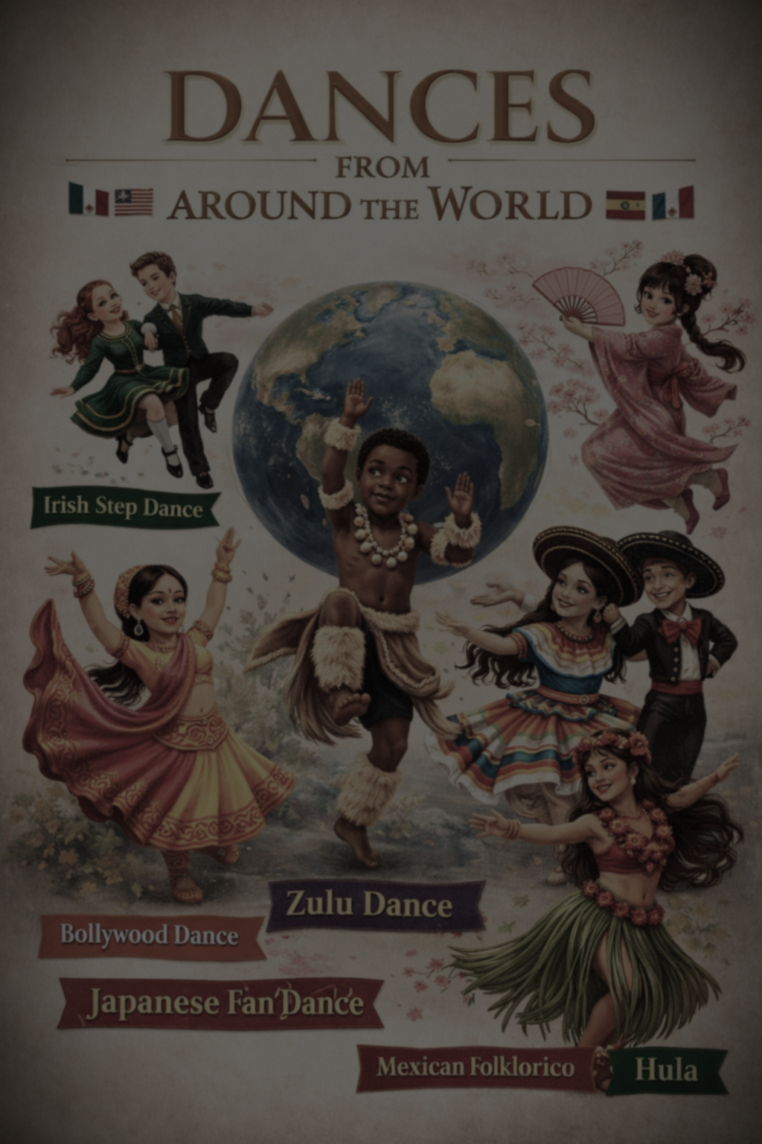

Dances of the world

Dance around the world workshops are exciting high energy, experience designed to introduce students to a variety of dance styles from different cultures. It’s often used during a schools cultural week to help students experience traditions from the world in engaging hands on way.

The different styles on offer can be a pick and mix from the genres below:
Spanish/flamenco dance - a strong, passionate and expressive art form, characterised by hand clapping, guitar, singing and intense footwork.
- Pasodoble - a dramatic dance modelled after the movements of a Spanish bull fight.
Props available such as: Castanets and tambourines
Greek Zorba - Usual danced in lines or circles holding hands. Steps are rhythmic and connected to community celebration.
Cossack - Very energetic and athletic style includes, jumps, turns and squatting kicks.
Haka - A powerful group dance from Māori culture. This includes chanting, stomping and strong facial expressions
Irish Dance - Fast footwork with a steel upper body focusing on rhythm and precision known from shows like: Riverdance
Scottish Dance - Often performed in sets with partners, a lively and fun style performed at social gatherings
Morris Dancing - Traditional English folk dance. Dancers use sticks, handkerchiefs
French Can-Can - A high energy cabaret dance famous for high kicks and splits, originating in the 19th century.
Tarantella - A fibrate fast paced Italian folk dance characterised by light rapid steps (tambourines available)
On booking please specify what style of dance is required

